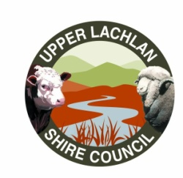

CROOKWELL II WIND FARM COMMUNITY FUND

PROJECT GUIDELINES

2023/2024

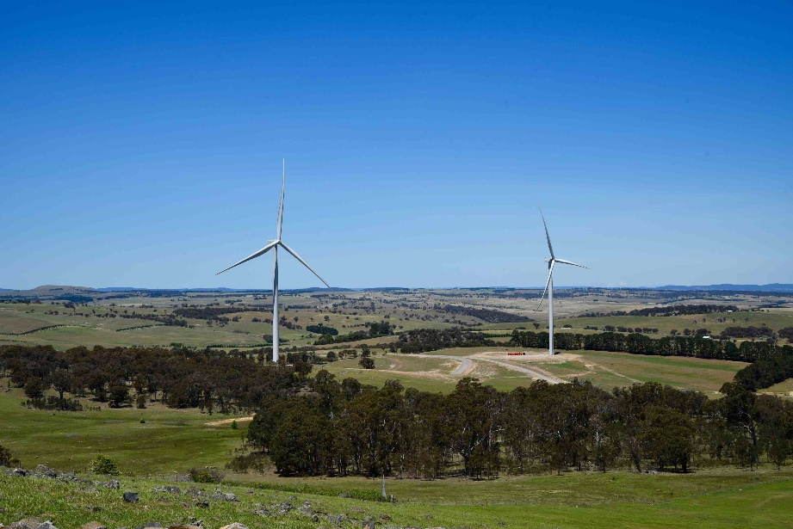

1. THE COMMUNITY FUND

1.1 General Guidelines

What is the Community Fund?

The Community Fund is one of the commitments by Crookwell II Wind Farm contained in the Community Enhancement Program (CEP). The Community Fund is intended to provide funds from Crookwell II Wind Farm to enhance and enrich community initiatives throughout the local community.

The Community Fund will provide financial contributions to community projects and initiatives such as equipment purchases, facility construction, renovation/rehabilitation projects, new programs or special funding that will enhance the community's quality of life and wellbeing.

Who administers the Community Fund?

A committee has been appointed to administer the Community Fund. This committee is made up of members of the community, representatives of the Upper Lachlan Shire Council as well as representatives of Crookwell II Wind Farm. The community representatives are elected every four years. Names of the community and wind farm representatives as well as the total funds for any one year are available from Upper Lachlan Shire Council.

How do I apply for funding?

Application forms will be made available on the Upper Lachlan Shire Council website and can be requested at any time at Council’s offices. Applications should be sent to Upper Lachlan Shire Council via email or post. Incomplete application forms will be returned.

Applications will be subject to the administration and review periods as outlined in this document.

Who can apply for Community Fund funding?

The eligible target community for the Community Fund includes community groups, projects/programs or facilities (Not for Profit) that are located within, or provided a direct benefit to, the community within a 20km radius of the Project.

Eligible property owner and resident applications would be given preference, however, non-permanent residents who work within the area and property owners who do not reside within the area are considered members of the community and are encouraged to apply.

The target community excludes landowners who have granted a lease or easement to the wind farm owner.

The purpose of the Community Fund is 'to broaden the benefits of the wind farm within the local community'. Therefore, landowners who already benefit through lease and easement payments from the wind farm owner are excluded from the target community for the CEP.

How often will applications be processed during the year?

Applications will be administered on an annual basis. The application process will follow the yearly timelines listed below:

- March to April – requests for applications;
- May – the Committee to review and prioritise the applications;
- May to June – prioritised applications forwarded to Council and the Company for ratification and endorsement;
- June – notification to applicants; and
- July to August – funds released.

Applicants will be informed of decisions after the end of the applicable review period. This will include feedback as to whether the application has been successful or not and relevant rationale.

Application processing and funding allocation will consider the funding cycle for other programs and the potential need for more than one funding opportunity each year.

What criteria will be used to evaluate applications?

Due to the limited funds available not all requests that meet the established criteria will be approved. The selection criteria will be confirmed and communicated to the community following the Committee's establishment. As a guide, general selection criteria may include:

Project benefits
- direct and indirect community benefit.
- quality of life/community wellness enhancement.
- program/ project operational efficiencies.
- demographics served.

Target community need
- public safety/improved access.
- provide a direct service to the community.
- Council/community support.

Availability of funding
- prior funding to applicant.
- demonstration of need for financial assistance.

Project/program viability
- background of applicant (ie. organisation size/representation, prior experience).
- the extent to which project or program duplicates other available facilities or programs in the area.

In addition to the above, applications must satisfy the following criteria:

- Applications must include at least two/three quotations that are less than six months old.
- Applications must include a Financial Management Plan.
- Funding will not be provided for sponsorship and/or day to day expenses of local sporting bodies, however, larger infrastructure items will be considered.
- The target community shall be within 10km of the wind farm and projects aimed at immediate neighbours would carry additional weight.
- Aim to improve the quality of life for the people in the Target Community.
- Aim to provide facilities and services for the target community.
- Not profit individuals or private entities.
- Provide full financial and legal disclosure on the activity and be subject to independent audit.

Programs or projects with benefits beyond the target community will be considered based on their capacity to benefit those people within the target community. Funding will not be allocated to projects/programs or activities that may harm wind farm operations.

All eligible applications from individuals, businesses and or organisations meeting the selection criteria will be reviewed and considered by the Committee. The Committee will meet to discuss and determine, through consensus, the successful application(s). Given that the final funding decisions are to be endorsed by both the Upper Lachlan Shire Council and the Company, if there is a discrepancy between the Upper Lachlan Shire Council's and the Company’s desires for the direction of funding and that of the Committee, then the application will be referred back to the Committee for further discussion and resolution.

Is the information in my application protected?

The Privacy and Personal Information Protection Act 1998 applies to information that is provided to the Committee. Personal information provided in the application form will be used for the purpose of administering the Community Fund only.

This information may be disclosed in response to an access request under the Government Information (Public Access) Act 2009, subject to applicable exceptions under the Act.

Once an application has been approved and funding issued, the recipient, project, amount funded and fiscal year will be a matter of public record.

How will I know if my application is successful?

All applications lodged will receive a response from the Committee, via email or post, advising of the success of their application. In addition, successful applications will be publicised through the Upper Lachlan Shire Council website and Facebook page and any other media deemed applicable by the Upper Lachlan Shire Council. All applications are treated as public documents. Should applicants not want details or components of their application made public, this should be stated clearly within the application.

When an application has been approved the Committee will make the necessary payment arrangements.

What if the project applied for changes once the funding has been approved?

If the scope of the project applied for changes, the applicants must request, in writing to the Committee, approval for changes. The scope of the program or project funding may only be adjusted with written approval from the Committee.

What happens if the actual costs are less than the approved funding?

If actual costs are less than the approved funding the applicant may:

      - Submit a written request to change the scope of the project, and if approved, apply the unexpended funds for this purpose.
      - Send a cheque, made payable to the Community Fund, for the remaining unexpended funds once the final amount has been confirmed by the Committee. Repayments must be submitted to the Community Fund.

1.2 PROJECT/PROGRAM REPORTING

What reporting is required for approved applications?

Reporting on completed projects is required to ensure that the target community and the Committee can be confident that allocated funds have been used effectively.

Standard templates will be provided to all successful applicants. Applicants must submit final reports using these templates. Funding recipients must permit a representative of the Community Fund to examine records relating to the expenditure of funds to determine if the grant has been properly spent.

When will the report on completed programs/projects be due?

Timing will be agreed at the application approval stage. Agreed project delivery timing will be decided upon on an individual project basis and will follow guidelines stipulated by the Committee.

Can the final reporting date be extended?

Yes. If a project/program is not completed within the required timeframe the applicant may request, in writing, an extension. All extension requests must be submitted to the Committee.

