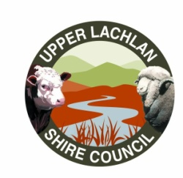
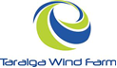

TARALGA WIND FARM COMMUNITY FUND
PROJECT GUIDELINES
2022 / 2023

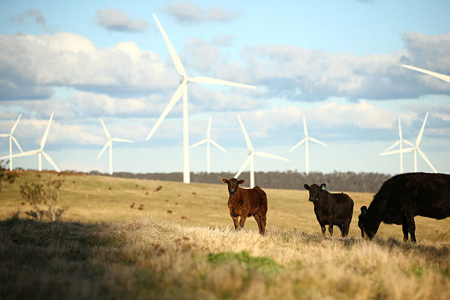

1. THE COMMUNITY FUND

1.1 General Guidelines

What is the Community Fund

The Community Fund (CF) is one of the commitments by Taralga Wind Farm contained in the Community Enhancement Program (CEP). The CF is intended to provide funds from Taralga Wind Farm to enhance and enrich community initiatives throughout the local community.

The Community Fund will provide financial contributions to community projects and initiatives such as equipment purchases, facility construction, renovation/rehabilitation projects, new programs or special funding that will enhance the community's quality of life and wellbeing.

Who administers the Community Fund

A committee has been appointed to administer the CF. This committee is made up of members of the community, representatives of the Upper Lachlan Shire as well as representatives of Taralga Wind Farm. The community representatives appointments to the Committee will be made by Council for a period of one year (commencing September each year) and Council will have the option to advertise for Community representatives or to reappoint existing members for a further term without advertising (up to a maximum of 4 years).
Names of the community and wind farm representatives as well as the total funds for any one year are available by contacting PacficHydro by email enquiries@pacifichydro.com.au

How do I apply for funding?

Application forms will be made available on the Upper Lachlan Shire Council website and can be requested at any time at Council’s offices. Applications should be sent to Upper Lachlan Shire Council via email or post. Incomplete application forms will be returned.

Applications will be subject to the administration and review periods as outlined in this document.

Who can apply for CF funding?

The eligible target community for the CF includes:

Incorporated or Not for Profit Community groups, funds, projects/programs or facilities that are located within, or provided a direct benefit to, the community within a 20km radius of the Project within the Upper Lachlan Local Government Area.

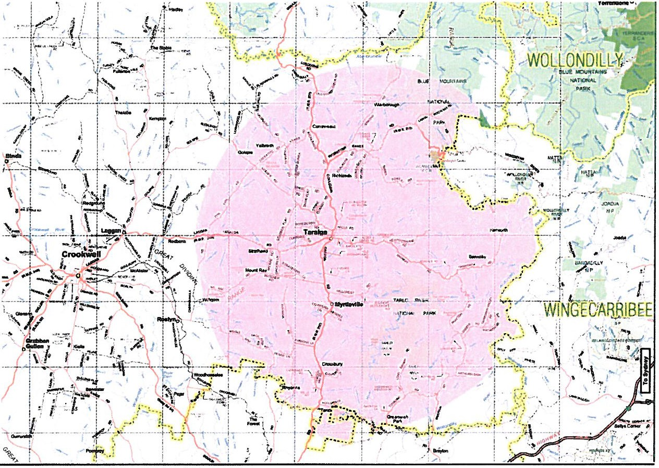

Map showing the extent of 20km radius from wind farm.

The target community excludes:

- Landowners who have granted a lease or easement to the wind farm owner.

The purpose of the CF is 'to broaden the benefits of the wind farm within the local community'. Therefore, landowners who already benefit through lease and easement payments from the wind farm owner are excluded from the target community for the CEP.

How often will applications be processed during the year?
Applicants will be informed of decisions after the end of the applicable review period. This will include feedback as to whether the application has been successful or not and relevant rationale.

Community Fund:

  - Applications will be administered on an annual basis. The application process will adhere to following yearly timelines:
    - January – April - requests for applications,
    - May - the Committee to review and prioritise the applications,
    - May – Prioritised applications forwarded to Council and the Company for ratification and endorsement,
    - June - Committee approval of applications and notification of applicants, and
    - July - funds released.

Application processing and funding allocation will consider the funding cycle for other programs and the potential need for more than one funding opportunity each year.

What criteria will be used to evaluate applications?

Due to the limited funds available all requests that meet the established criteria may not be approved. General selection criteria may include:

Project benefits
- direct and indirect community benefit.
- quality of life/community wellness enhancement.
- program/ project operational efficiencies.
- demographics served.

Target community need
- public safety/improved access.
- provide a direct service to the community.
- Council/community support.

Availability of funding
- prior funding to applicant.
- demonstration of need for financial assistance.

Project/ program viability
- background of applicant (i.e. organisation size/ representation, prior experience).
- the extent to which project or program duplicates other available facilities or programs in the area.

In addition to the above, applications must satisfy the following criteria:

- The target community shall be within 20km of the wind farm within the Upper Lachlan Local Government Area.
- Aim to improve the quality of life for the people in the Target Community.
- Aim to provide facilities and services for the target community.
- Incorporated or Not for Profit entities.
- Provide full financial and legal disclosure on the activity and be subject to independent audit.
- The project must not have a detrimental or negative impact on other community facilities and services.
- Projects funded as part of the Taralga Wind Farm Community Enhancement Fund may be subject to conditions which may include but not be limited to compliance with relevant safety or Australian Standards, as deemed appropriate by the Committee.
- Any applications over $15 thousand dollars must be accompanied by at least one quote, however two is preferred.

Programs or projects with benefits beyond the target community will be considered based on their capacity to benefit those people within the target community.

All eligible applications, from Incorporated or Not for Profit Entities meeting the selection criteria will be reviewed and considered by the Committee. The Committee will meet to discuss and determine, through consensus, the successful application(s). Given that the final funding decisions are to be endorsed by both the Upper Lachlan Shire Council and the Company, if there is a discrepancy between the Upper Lachlan Shire Council's and the Company’s desires for the direction of funding and that of the Committee, then the application will be referred back to the Committee for further discussion and resolution.

Is the information in my application protected?

The Privacy and Personal Information Protection Act 1998 applies to information that is provided to the Committee. Personal information provided in the application form will be used for the purpose of administering the Community Fund only.

This information may be disclosed in response to an access request under the Government Information (Public Access) Act 2009, subject to applicable exceptions under the Act.

Once an application has been approved and funding issued, the recipient, project, amount funded and fiscal year will be a matter of public record.

How will I know if my application is successful?

All applications lodged will receive a response from the Committee, via email or post, advising of the success of their application. In addition, successful applications will be publicised through the Upper Lachlan Shire Council website, "The Voice" newsletter and any other media deemed applicable by the Upper Lachlan Shire Council. All applications are treated as public documents. Should applicants not want details or components of their application made public, this should be stated clearly within the application.

When an application has been approved the Committee will make the necessary payment arrangements.

What if the project applied for changes once the funding has been approved?

If the scope of the project applied for changes, the applicants must request, in writing to the Committee, approval for changes. The scope of the program or project funding may only be adjusted with written approval from the Committee.

What happens if the actual costs are less than the approved funding?

If actual costs are less than the approved funding the applicant may:

      - Submit a written request to change the scope of the project, and if approved, apply the unexpended funds for this purpose.
      - Send a cheque, made payable to the Community Fund, for the remaining unexpended funds once the final amount has been confirmed by the Committee. Repayments must be submitted to the Community Fund.

1.2 PROJECT/PROGRAM REPORTING

What reporting is required for approved applications?

Reporting on completed projects is required to ensure that the target community and the Committee can be confident that allocated funds have been used effectively.

Standard templates will be provided to all successful applicants. Applicants must submit final reports using these templates. Funding recipients must permit a representative of the Community Fund to examine records relating to the expenditure of funds to determine if the grant has been properly spent.

When will the report on completed programs/projects be due?

Timing will be agreed at the application approval stage. Agreed project delivery timing will be decided upon on an individual project basis and will follow guidelines stipulated by the Committee.

Can the final reporting date be extended?

Yes. If a project/program is not completed within the required timeframe the applicant may request, in writing, an extension. All extension requests must be submitted to the Committee.

